**SQL-Leet Code-Challenge**

**Q1). Finding the Duplicate records in the table?**

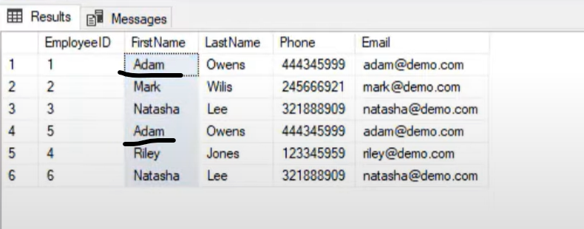

SOLUTION:-

SELECT FIRSTNAME, LASTNAME, COUNT(*) total count FROM Employess

GROUP BY FIRSTNAME, LASTNAME'

HAVING COUNT(*)>1

***************Using the Rank Function*******************

With Employee_duplicates as

(SELECT Employee_ID, FIRSTNAME, LASTNAME,

RANK() OVER(Partition by  FIRSTNAME, LASTNAME order by Employee_ID) as RANK_NUMB

FROM Employee)

DELETE FROm Employee_duplicates where RANK_NUMB>1

**Q2). Finding Nth highest salary of the employee from the table?**

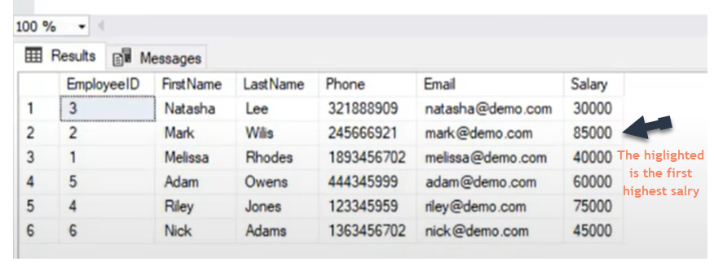

SELECT Firstname, lastname,Department, SALARY from EMPLOYEE

WHERE SALARY = (SELECT max(SALARY) FROM EMPLOYEE)

**Getting the highest salary by using the desc order salary**

select top 1 * from EMPLOYEE -----Top Two highest salaries

order by SALARY desc

select top 2 * from EMPLOYEE

order by SALARY desc

**Getting the any highest salary from the result set i.e getting the 15th highest salary**

select top 1 * FROM

(select top 15 * from EMPLOYEE

order by SALARY desc

)

order by SALARY ASC---->getting the 15th Hishest salary as it's the lowest salary out of the 15 records dynamically…

We can apply same logic for any records

SELECT * FROM EMPLOYESS

ORDER BY SALARY DESC

limit 1 offset 14 ------This will result the 15th  highest salary

**Getting the higest salaries based upon the Dense_Rank function**

with Employee_salary as (

SELECT *, DENSE_RANK() OVER(PARTITION BY DEPARMENT ORDER BY SALARY DESC) AS rank FROM EMPLOYESS

)

select * from Employee_salary where rank =2 -----will give the second higest salary

**Q3). Finding the Employees corresponding Managers details from the table ?**

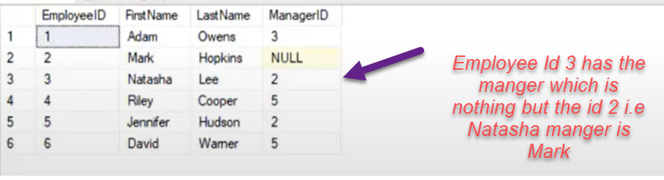

SOLUTION:-

Select emp.Fistname + '' + emp.Fistname as EmployeeName

mngr.Fistname + '' + mngr.Fistname as MangerName

from EMPLOYEE emp INNER JOIN EMPLOYEE mngr

ON emp.Employee_id = mngr.Manger_id

**Q3). Finding the employees who’s salary is greater than their managers salary?**

SELECT FirstName,LastName,Employee_Id,Manager_Idsalary from Employee emp

where salary>= (select salary from Employee mng where emp.Employee_Id = mng.Manager_Id)

SELECT FirstName,LastName,Employee_Id,Manager_Idsalary from Employee emp inner join  Employee mng

ON emp.Employee_Id = mng.Manager_Id

AND emp.salary>mng.salary

**Q3). Find the Employee salary who’s having less than average salary of the department but greater than the average salary of any other departments?**

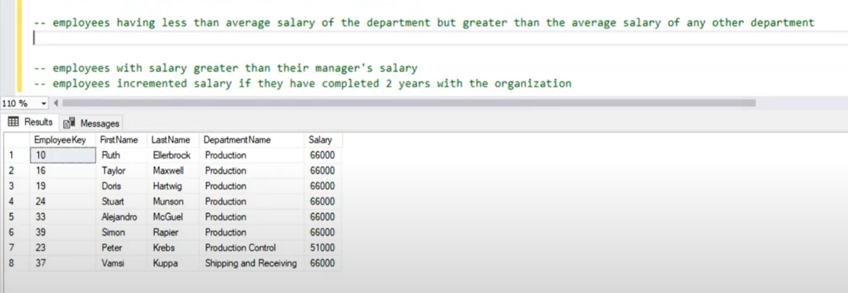

SELECT EmployeeKey,Firstname,LastName,Emp.DepartmentName,salary from EMPLOYEES Emp

INNER JOIN

(

SELECT DepartmentName,avg(salary) as Avgsale from EMPLOYEES

GROUP BY

DepartmentName) as DeptAvg

ON Emp.DepartmentName = DeptAvg.DepartmentName

AND Emp.salary<= DeptAvg.Avgsale

where Emp.salary> ANY(select avg(salary) from EMPLOYEE GROUP BY DepartmentName)

**Q3). Find The Employees with highest salary in the department wise**

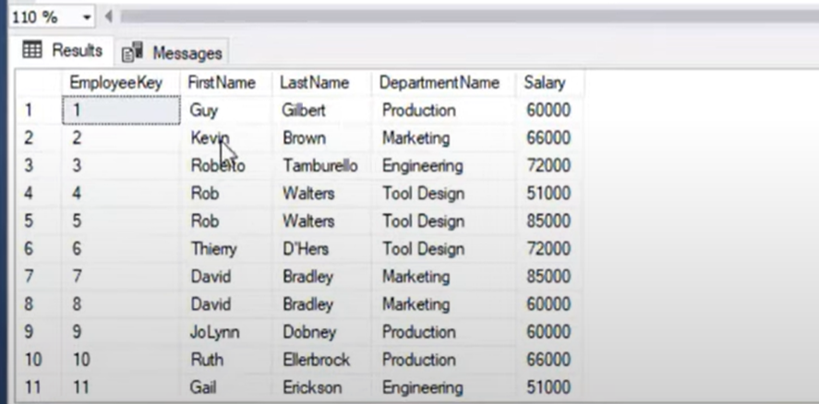

SOLUTION:-

SELECT EmployeeKey,Firstname,LastName,Emp.DepartmentName,salary from EMPLOYEES Emp

INNER JOIN

(

SELECT DepartmentName,MAX(salary) as maxsala from EMPLOYEES

GROUP BY

DepartmentName) as MaxSalesEmp

ON Emp.DepartmentName = DeptAvg.DepartmentName

AND Emp.salary =  MaxSalesEmp.maxsala

Alternate Query with the Rank

SELECT EmployeeKey,Firstname,LastName,DepartmentName,salary

RANK() OVER(partition by DepartmentName order by salary desc) as Rank_sale

from EMPLOYEES

**Q3). Find employees salary who is having greater than average salary of the department?**

SELECT EmployeeKey,Firstname,LastName,Emp.DepartmentName,salary from EMPLOYEES Emp

INNER JOIN

(

SELECT DepartmentName,Avg(salary) as Avgsal from EMPLOYEES

GROUP BY

DepartmentName) as AvgEmpsale

ON Emp.DepartmentName = DeptAvg.DepartmentName

AND Emp.salary >  AvgEmpsale.Avgsal

Other Solution

SELECT E1.EMPNAME,E1.DeptId, E1.SALARY

FROM EMPLOYEE E1 WHERE SALARRY >

(

    SELECT Avg(SALARRY) FROM EMPLOYEE E2

    ON E1.DeptId = E2.DeptId

)

**Q3). Capitalization of the first letter of the string ?**

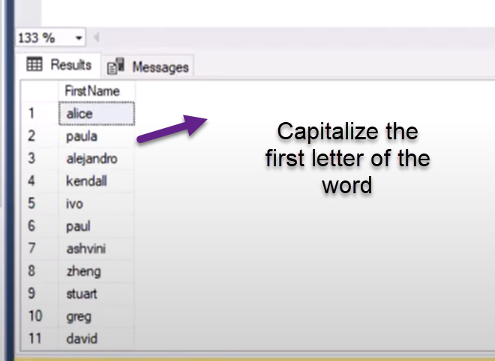

SELECT UPPERCASE(Left(NAME,1)) + Substr(NAME,2,length(Name)) FROM EMPLOYEE

**Q3). Find the retainment age for the date birth to employee?**

SELECT firstname,lastname, Add_YEARS("Birthday",60) as Retairment_age from Employee

**Q3). Counting the number of occurrences of a character in the String?.**

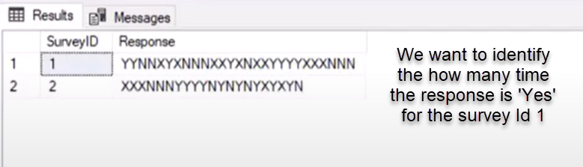

Select SurveyId, Response,Totallength-required_length as occurence of Y

FROM

(SELECT SurveyId, Response, length(Response) as Totallength, Replace(Response,'Y',''),length(Replace(Response,'Y','')) as required_length

from Employee)

**Q3). Find the names that starts and ends with the character ‘a’?**

SELECT Firstname from Employee

where  Firstname like '%a' AND Firstname like 'a%'

SELECT Firstname from Employee

where  Firstname like '%a'

AND Firstname like_regexpr '[A-Z]'

**Q3). Find the lower case values from the string column values?**

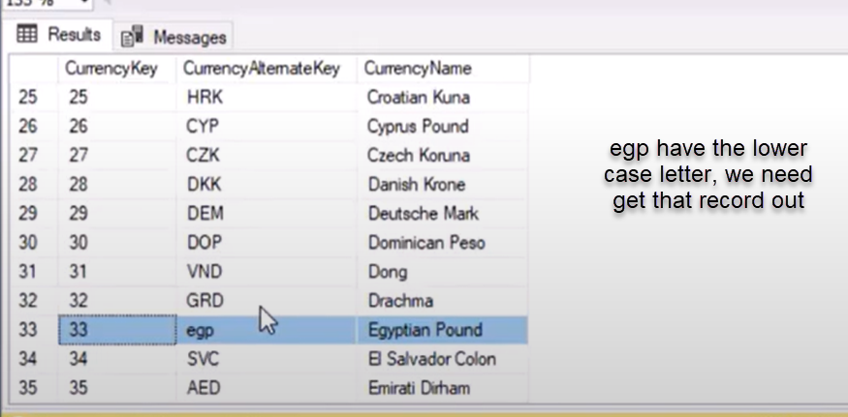

SELECT CurrencyAlternateKey, uppercase(CurrencyAlternateKey) From CurrencyTable

WHERE upper(CurrencyAlternateKey)!= CurrencyAlternateKey

**Q3). Difference between the Count(*),Count(1) and Count(column)**

**The Count (*) will include the null values as the count value in the result set**

**The Count(column) will not include the counting the null values in the result set meaning it will include only the not null values in the result**

**Q3). Find the No sales for consecutive days and identify the gaps in days**

SELECT EmployeeId, Firstname,lastname, order_date,lead_date

DAYS_BETWEEN(order_date,lead_date) as gap

(

SELECT EmployeeId, Firstname,lastname, order_date,

lead(order_date) Over(order by order_date) as lead_date

FROM Employees

order by order_date

)

WHERE DAYS_BETWEEN(order_date,lead_date) >1

**Alternate solution**

SELECT EmployeeId, Firstname,lastname, order_date,

Days_Between(Order_Date,(lead(order_date) Over(order by order_date))) as gap

FROM Employees

order by order_date

**Where** Days_Between(Order_Date,(lead(order_date) Over(order by order_date)))>1

**Q3). Comparing the current sales amount with the Previous sales amount for the year and month level ?.**

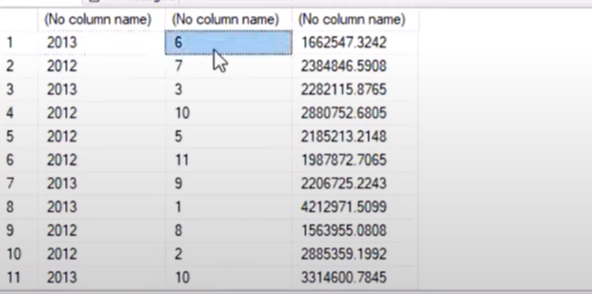

SELECT Employee, year, month, SalesAmount-previoussales

FROM

(Select Employee, year(Orderdate) as Year, month(orderdate) as month, sum(SalesAmount) as SalesAmount,

Lag(sum(SalesAmount)) OVER(order by  year(Orderdate), month(orderdate)) as previoussales

From Sales_Info

Group by Employee, year(Orderdate), month(orderdate)

)

**Q3). Comparing the current month of current year sales amount with the previous year of the same month sales amount?**

Select Employee, year(Orderdate) as Year, month(orderdate) as month, sum(SalesAmount) as SalesAmount,

Lag(sum(SalesAmount),12) OVER(order by  year(Orderdate), month(orderdate)) as previoussales

From Sales_Info

Group by Employee, year(Orderdate), month(orderdate)

**Lag(sum(SalesAmount),12)---> essentialy this will populate the null value for the previoussales column values and populate**

**previoussales value for the previous first month side**

**Q3). Comparing the current month of current year sales amount with all the remaining months ?**

Select Employee, year(Orderdate) as Year, month(orderdate) as month, sum(SalesAmount) as SalesAmount,

Lag(sum(SalesAmount), month(orderdate)-1) OVER(order by  year(Orderdate), month(orderdate)) as previoussales

From Sales_Info

Group by Employee, year(Orderdate), month(orderdate)

**Q3). Extracting the domain name from the given email id?**

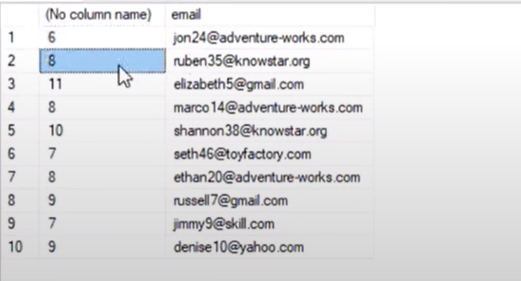

SELECT CharIndex('@',email) from Employee

SELECT count(*), Rightstr(email,lenghth(email)-CharIndex('@',email)) from Employee

Group by

Rightstr(email,lenghth(email)-CharIndex('@',email))

**Q3). How Find all levels of employee manager hierarchy Recursion ?**

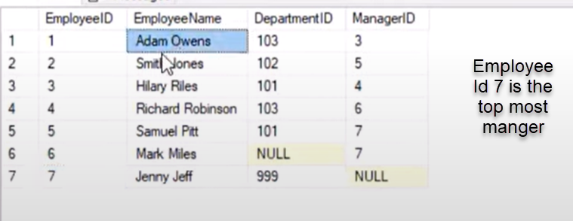 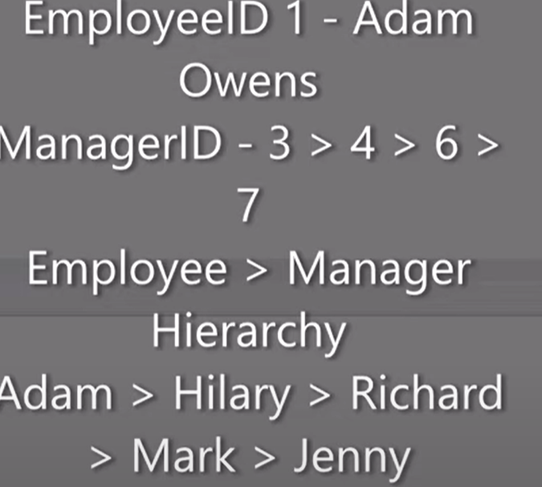

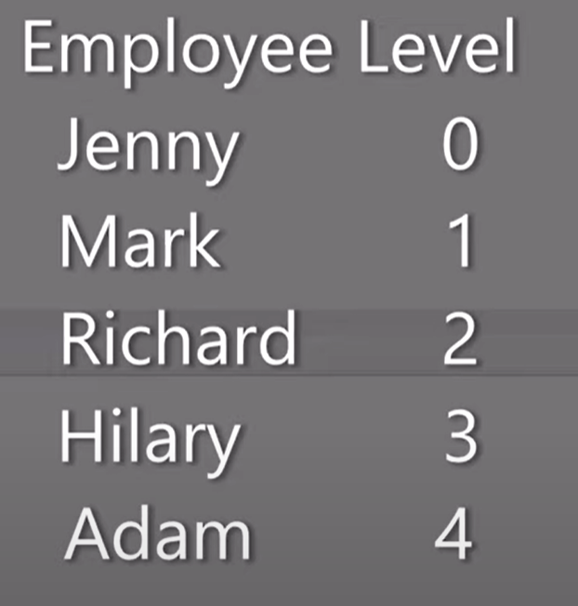

With MangHier as

( SELECT EmployeeId, EmployeeName, ManagerId, 0 as EmployeeLevel

From Employee

WHERE

ManagerId is null

UNION ALL

SELECT emp.EmployeeId, emp.EmployeeName, emp.ManagerId, EmployeeLevel+1 as EmployeeLevel

From Employee emp

INNER JOIN MangHier as mgr

ON emp.ManagerId = mgr.EmployeeId

)

SELECT * FROM MangHier;

**Q3). Finding the Rank,Row_Number and dense Rank?**

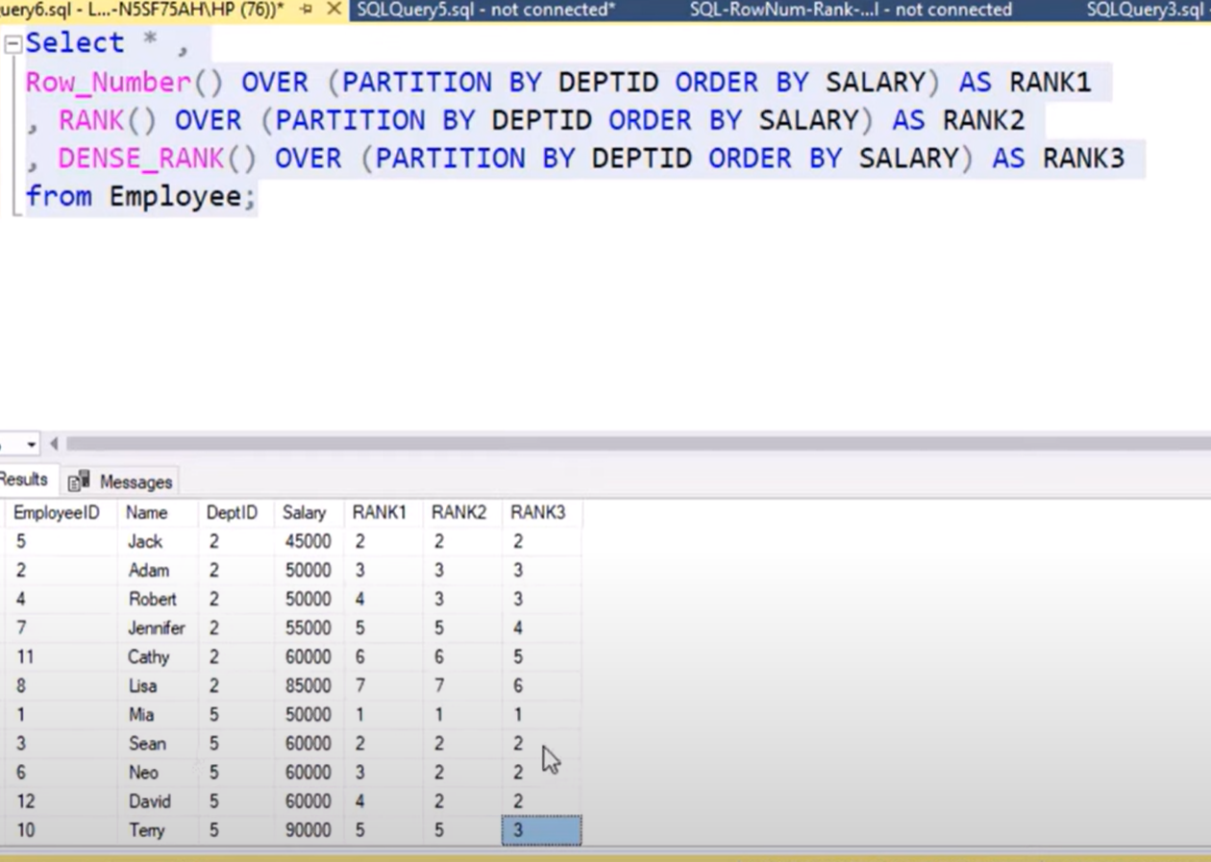

**Q3). How many times the String ‘Yes’ is repeated?**

SELECT StringVal, (strlengt-yeslength)/length('yes') as find

FROM

(

SELECT StringVal,length(replace(StringVale,'yes','')) as yeslength, length(StringVale) as strlengt)

**Q3). Display the minimum and Max sequence?.**

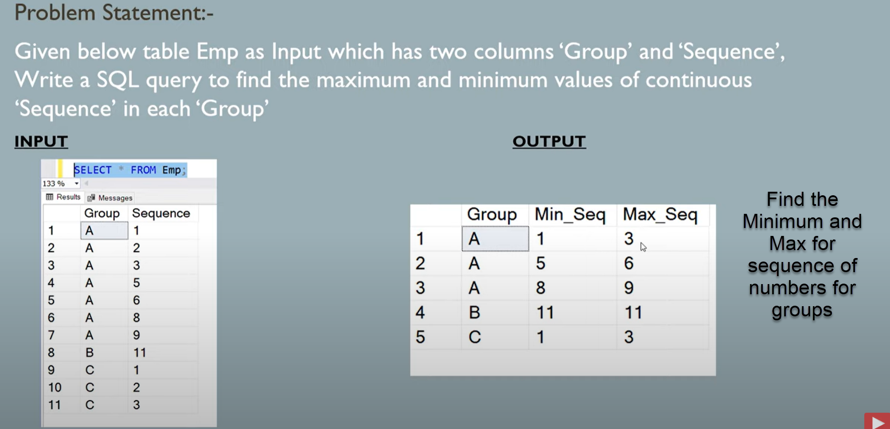

SELECT Group,

Max(Sequence),

Min(Sequence)

FROM

(SELECT Group, Sequence, ROW_NUMBER() OVER(Partition by Group order by Sequence) as Rank,

Sequence- ROW_NUMBER() OVER(Partition by Group order by Sequence) GroupRank

FROM EMPLOYEE_TABLE

)

GROUP BY

Group,

GroupRank

order by GroupRank

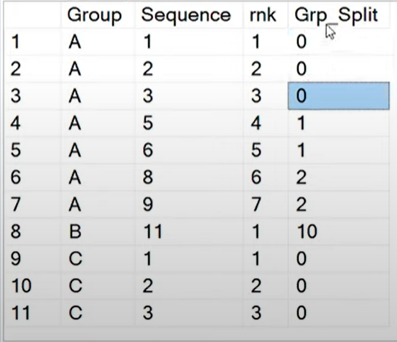

**Q3). Display Previous years marks whose Total marks are greater than or equal to previous year ?.**

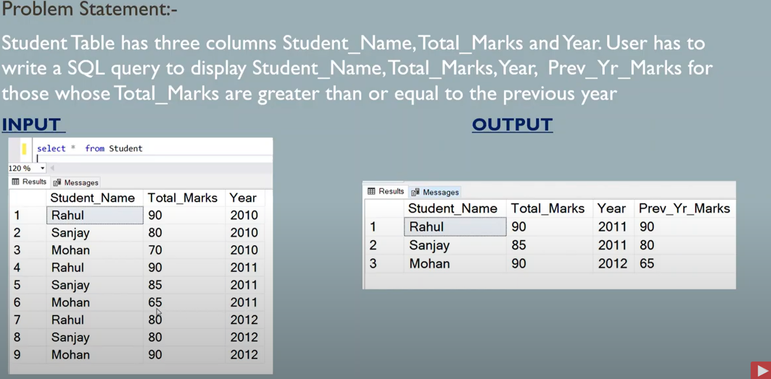

SELECT StudentName,year,Total_Marks

FROM

(SELECT StudentName,year,Total_Marks,

LAG(Total_Marks) over(partition StudentName order by year desc) as Previouse_Marks,

CASE WHEN Total_Marks>= (LAG(Total_Marks) over(partition StudentName order by year desc)) Then 1 else 0 end as Flag

FROM STUDENTS

)

WHERE Flag=1;

**Q3).Finding the product how many times order ?.**

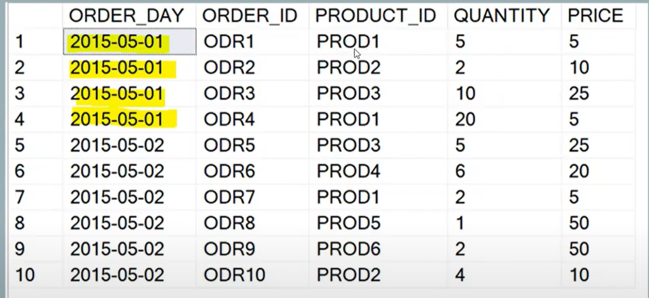

SELECT Product_id, count(Product_id) as count , count(distinct order_day)

from

GROUP BY Product_id

HAVING count(distinct order_day)>1

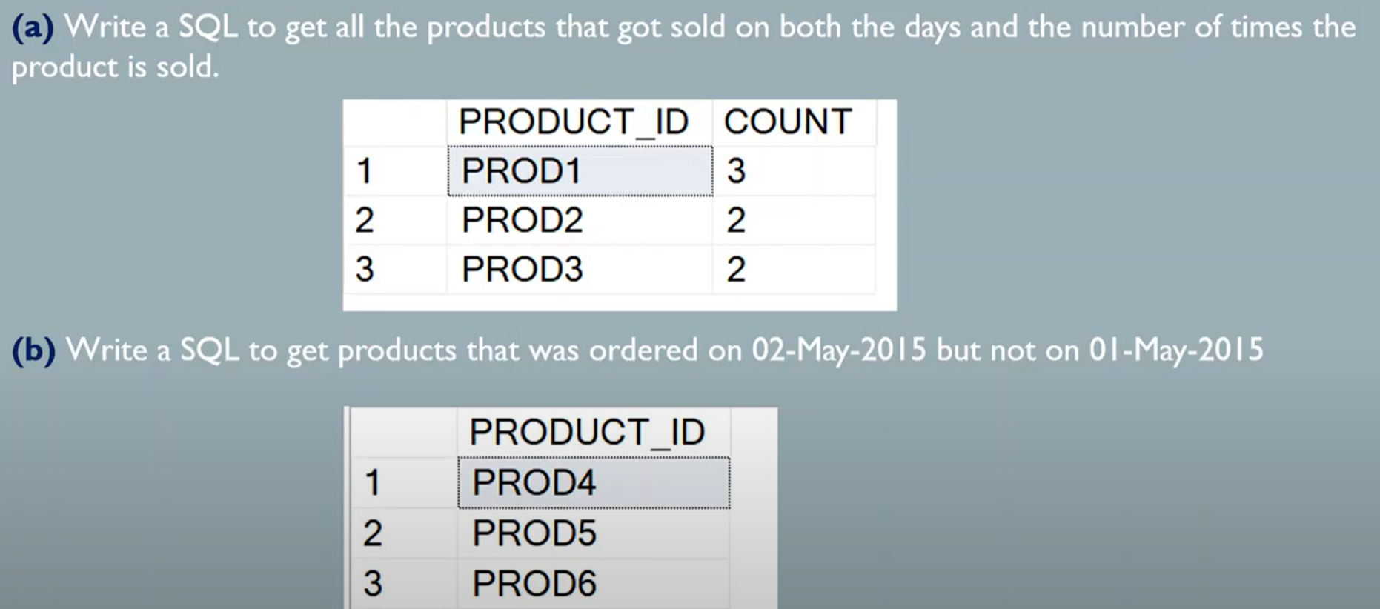

**Q3). Find the Products that was sold on the 2nd May but on the 1st May.**

SELECT DISTINCT(PRODUCT_ID) FROM ORDER_TABLE

WHERE ORDER_DAY = '2015-05-02'

AND PRODUCT_ID NOT IN(SELECT PRODUCT_ID FROM ORDER_TABLE WHERE ORDER_DAY = '2015-05-01')

**------------------------------------------**

SELECT A.PRODUCT_ID,B.PRODUCT_ID

FROM

(

(SELECT PRODUCT_ID FROM ORDER_TABLE WHERE ORDER_DAY = '2015-05-01')

as a LEFT OUTER JOIN

(

SELECT PRODUCT_ID FROM ORDER_TABLE WHERE ORDER_DAY = '2015-05-01'

) as b

on a.PRODUCT_ID = b.PRODUCT_ID

)

WHERE b.PRODUCT_ID is null

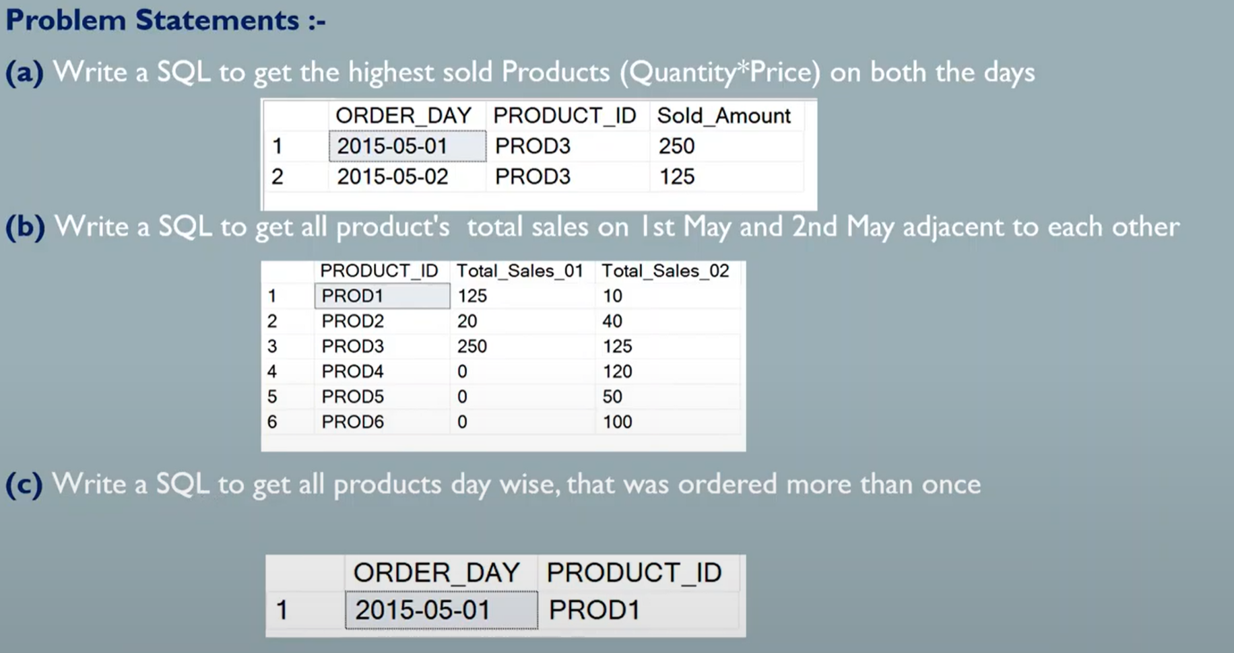

**Q3). Write the SQL to get highest sold products (Quantity*Price) on both days?**

SELECT ORDER_DAY, PRODUCT_ID,TOTAL FROM

(

(SELECT ORDER_DAY, PRODUCT_ID, MAX(QUANTITY*PRICE) AS TOTAL FROM ORDER_TABLE

WHERE ORDER_DAY='2015-05-01'

GROUP BY

ORDER_DAY, PRODUCT_ID

)

UNION ALL

(SELECT ORDER_DAY, PRODUCT_ID, MAX(QUANTITY*PRICE) AS TOTAL FROM ORDER_TABLE

WHERE ORDER_DAY='2015-05-01'

GROUP BY

ORDER_DAY, PRODUCT_ID

)

)

**Q3). Write the SQL to get 2015-05-01 and 2015-05-02 product total sales in separate columns in the output?**

SELECT  PRODUCT_ID, SUM(TOTAL_SALE_1) AS TOTAL_SALE_1, SUM(TOTAL_SALE_2) ASS TOTAL_SALE_2

FROM

(

SELECT ORDER_DAY, PRODUCT_ID,  SUM(QUANTITY*PRICE) AS TOTAL_SALE_1  FROM ORDER_TABLE

WHERE ORDER_DAY='2015-05-01'

GROUP BY

ORDER_DAY,

PRODUCT_ID

UNION ALL

SELECT ORDER_DAY, PRODUCT_ID,  0 TOTAL_SALE_1, SUM(QUANTITY*PRICE) AS TOTAL_SALE_2  FROM ORDER_TABLE

WHERE ORDER_DAY='2015-05-02'

GROUP BY

ORDER_DAY,

PRODUCT_ID

)

GROUP BY

PRODUCT_ID

**Q3). Write the SQL to Products that was ordered twise as day.**

SELECT ORDER_DAY PRODUCT_ID,count(*)

from

GROUP BY ORDER_TABLE

HAVING count(*)>1

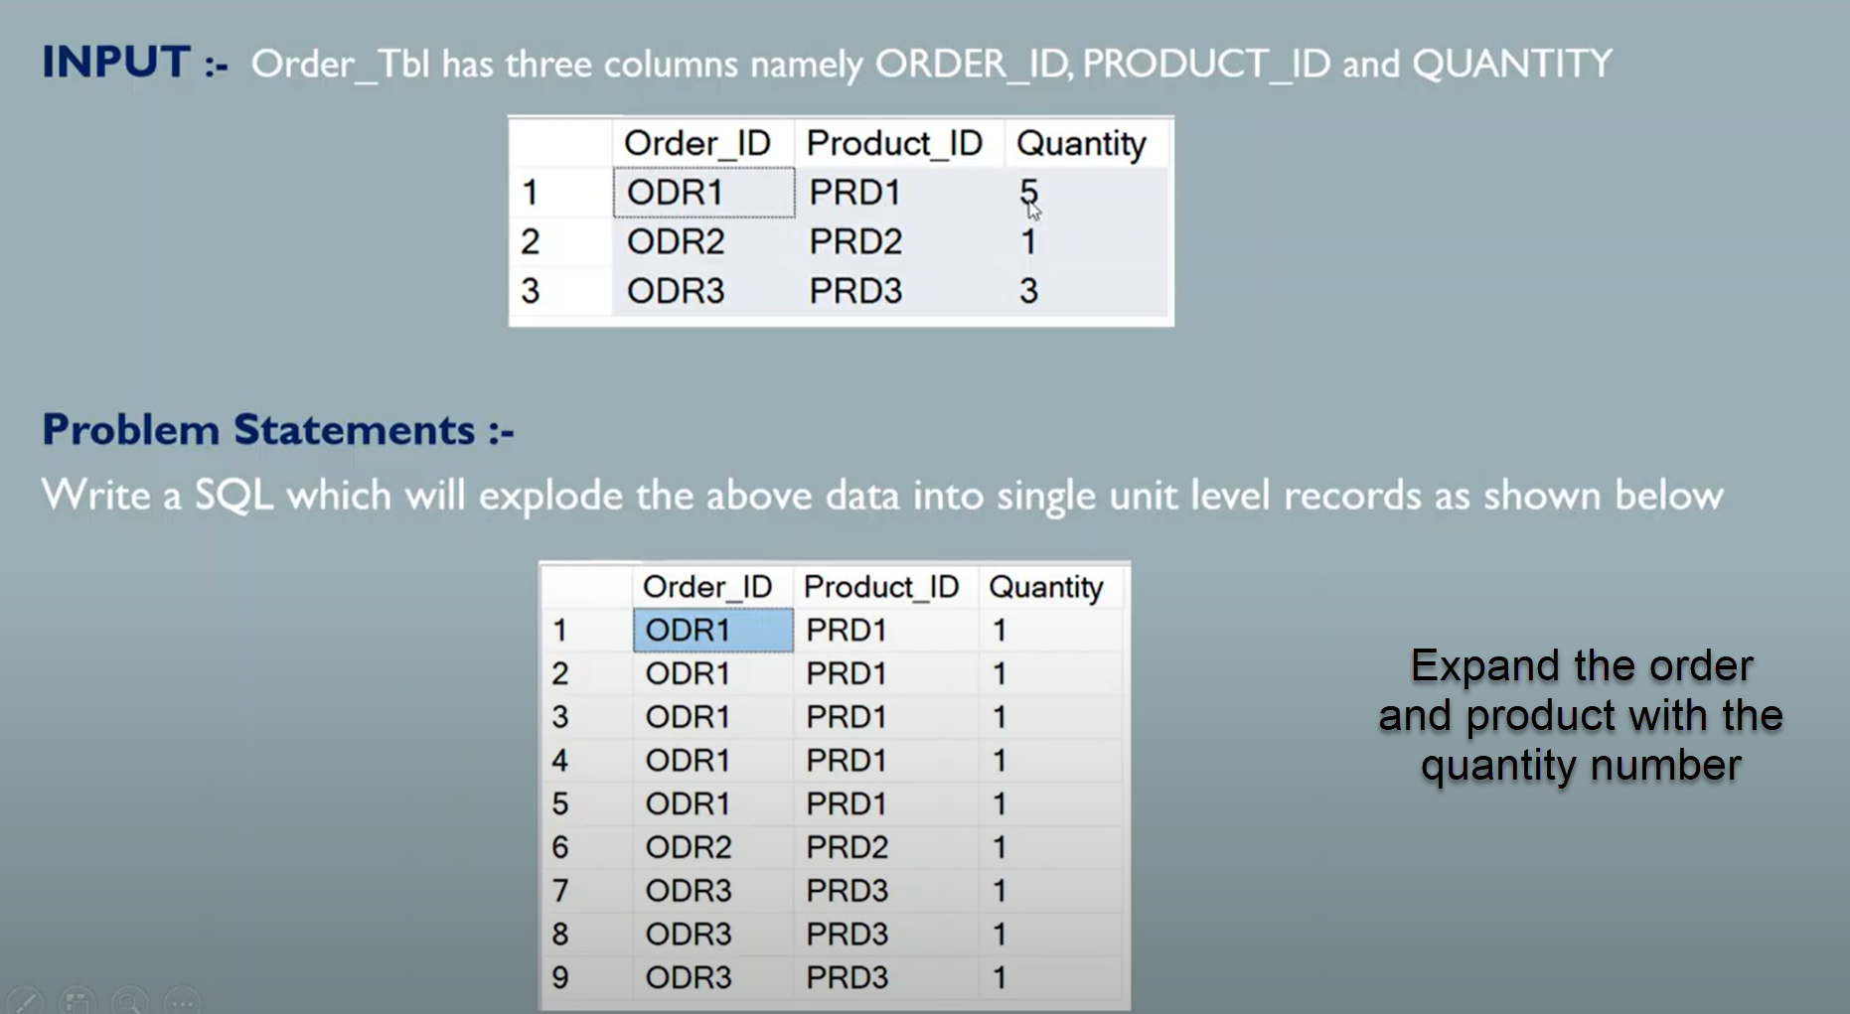

**Q3). Expand the Order_id and Product_id records to multiple records as per the Quantity number**

With CTE as

(----Anchor Query

SELECT ORDER_ID, PRODUCT_ID, 1 AS QUANTITY, 1 AS CNT

FROM ORDER_TABLE

UNION ALL

SELECT A.ORDER_ID, A.PRODUCT_ID,B.QUANTITY,CNT+1

FROM ORDER_TABLE AS A INNER JOIN CTE AS B

ON A.PRODUCT_ID = B.PRODUCT_ID

WHERE B.CNT+1 <= A.QUANTITY

)

SELECT ORDER_ID, PRODUCT_ID, QUANTITY FROM CTE;

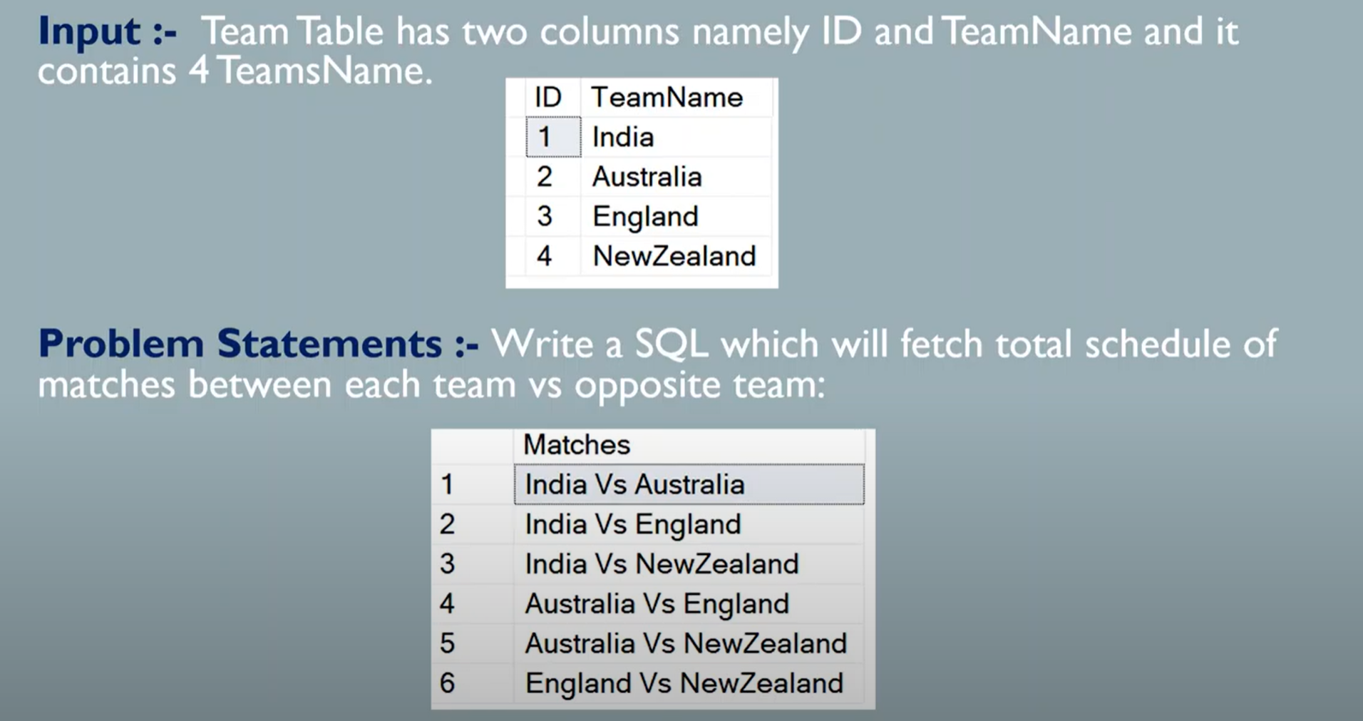

**Q3). Find the possible matches between the Teams**

SELECT T1.ID, concat(concat(T1.TEAM,' vs '),T2.TEAM)

FROM TEAM AS T1

INNER JOIN

(SELECT ID, TEAM FROM TEAM )AS T1

ON T1.ID < T2.ID

**Q3). Playing the Matches within the team itself?**

SELECT T1.ID, concat(concat(T1.TEAM,' vs '),T2.TEAM)

FROM TEAM AS T1

INNER JOIN

(SELECT ID, TEAM FROM TEAM )AS T1

ON T1.ID = T2.ID

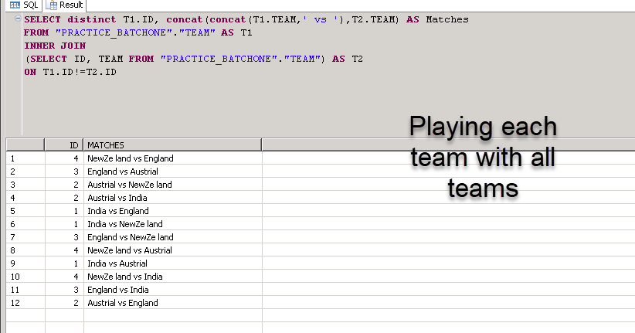

**Q3). Find the output for the below joining conditions**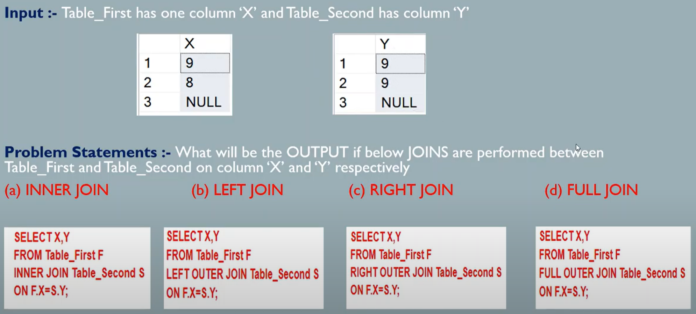

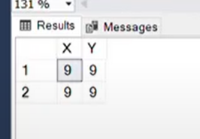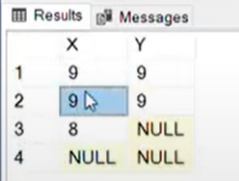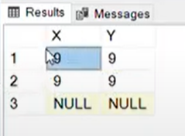

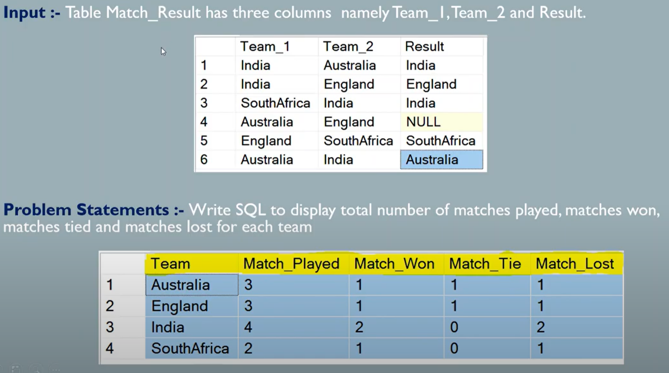

**Q3). Find the number of matched played, Match Won, Match lost and Match Tie?.**

**Copy the Code from the ThinSolution**

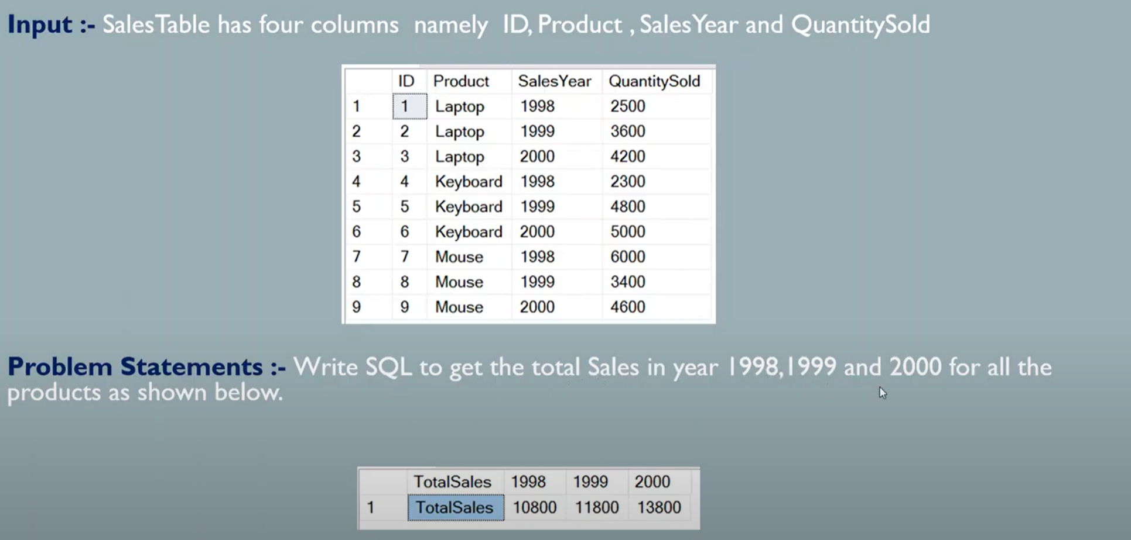

**Q3). Find the Total sales for the year for 1998,1999,2000**

SELECT 'Total_Sales' sa Total_Sales, SUM(1998) AS '1998', SUM(1999) AS '1998', SUM(2000) AS '2000'

(CASE WHEN SALES_YEAR = 1998 Then SUM(QuantitySold) End '1998',

CASE WHEN SALES_YEAR = 1999 Then SUM(QuantitySold) End '1999',

CASE WHEN SALES_YEAR = 2000 Then SUM(QuantitySold) End '2000',

FROM SALES

GROUP SALES_YEAR

)

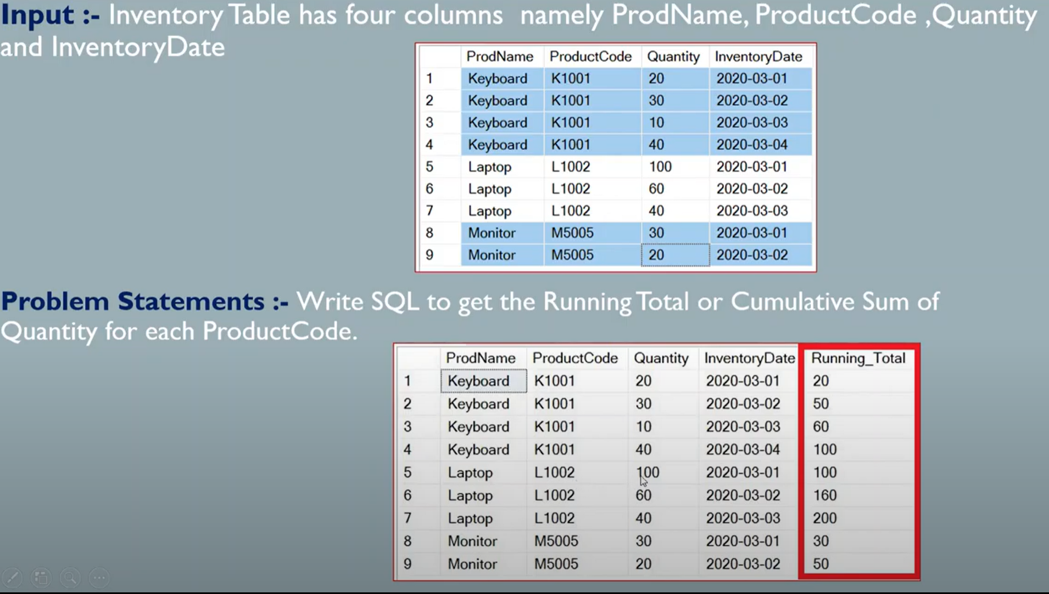

**Q3). Find the Cumulative Sum base on the Product Code?**

SELECT PRODUCTNAME, PRODUCTCODE,QUANTITY,INVENTORYDATE

SUM(QUANTITY) OVER(PARTITION BY PRODUCTCODE ORDER BY INVENTORYDATE )

FROM PRODUCT_ORDER

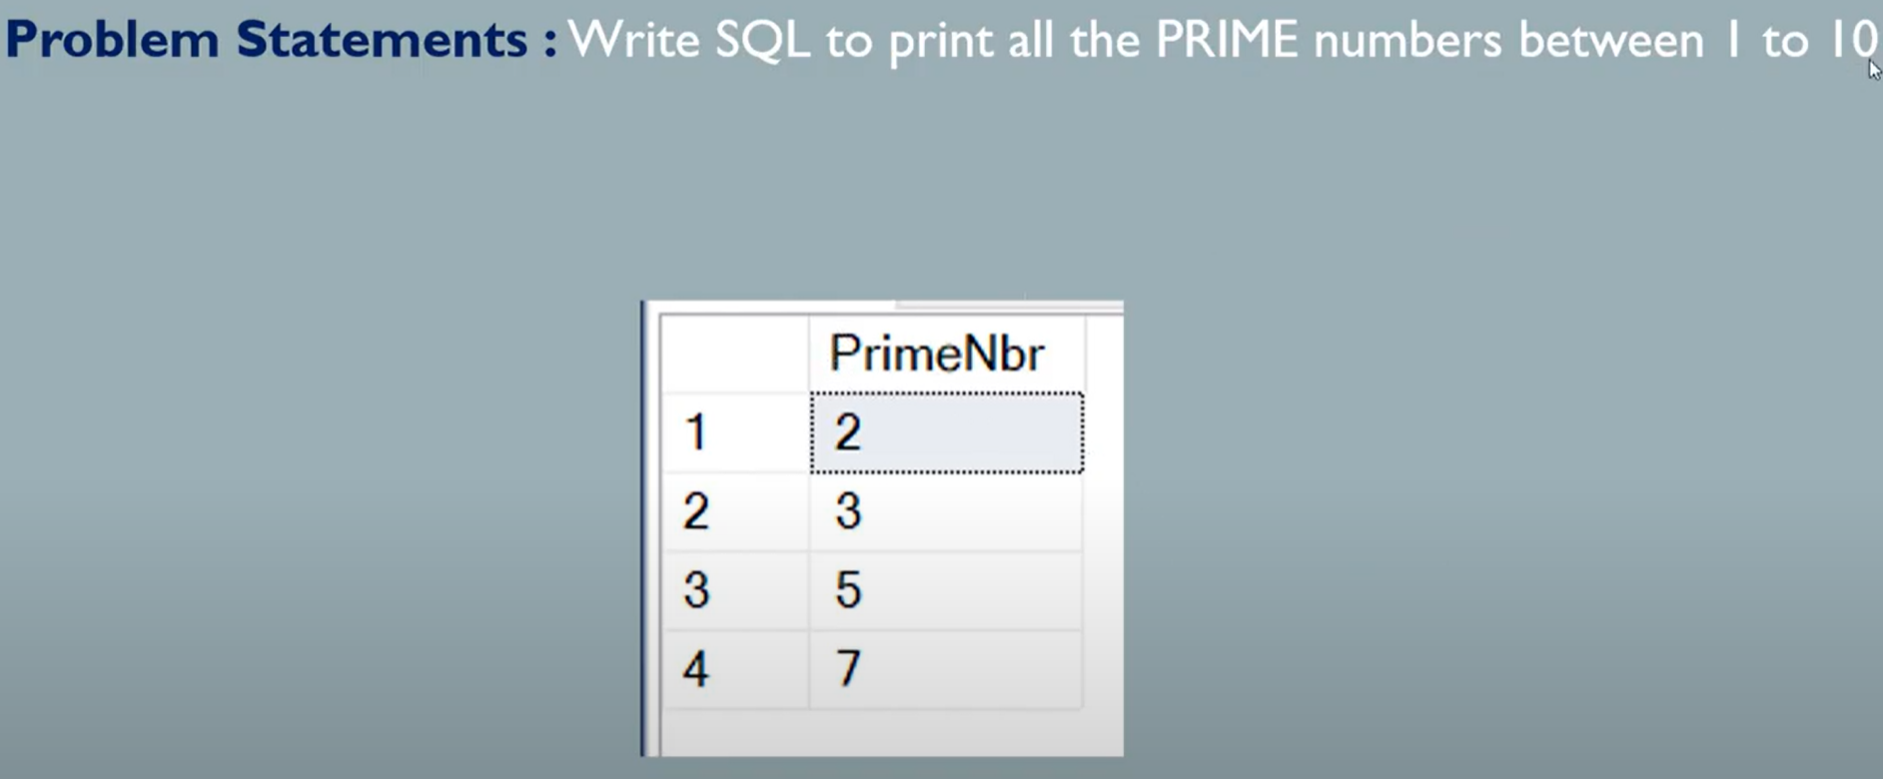

**Q3). Find the Prime numbers from 1 to 10 ?.**

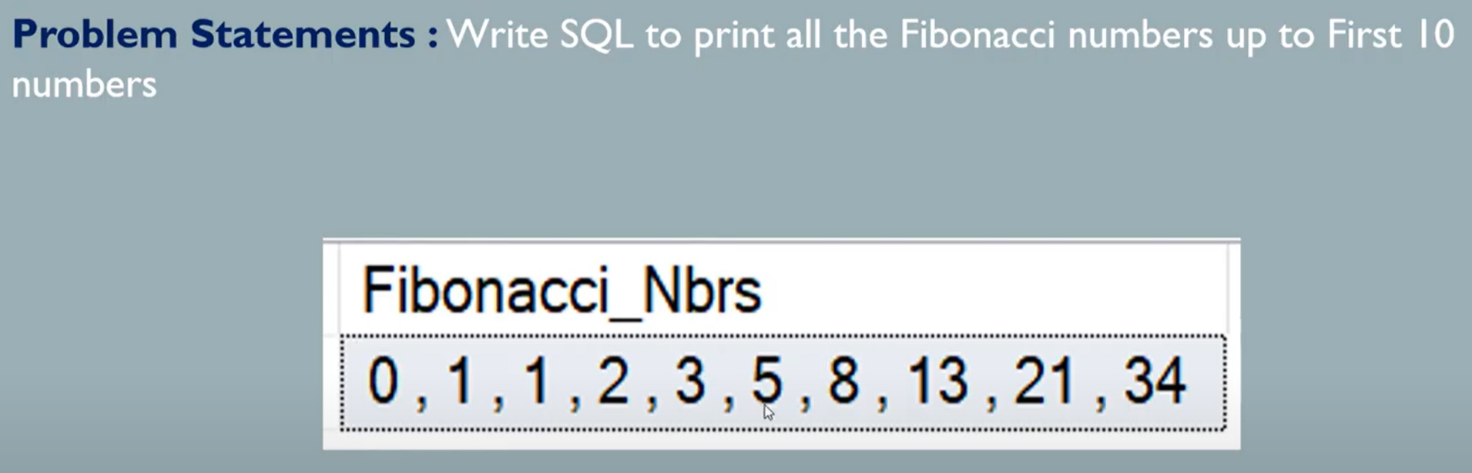

**Q3). Find the Fibonacci Series Numers ?.**

With FIBONACCI as (

SELECT 0 as FIRST, 1 AS SECOND , 1 AS STEP FROM DUMMY

UNION ALL

SELECT SECOND, SECOND+FIRST, STEP+1

FROM FIBONACCI

WHERE STEP<10

)

SELECT STRING_ARRG(FIRST,',') AS Fibonaci_series from FIBONACCI

GROUP BY

FIRST

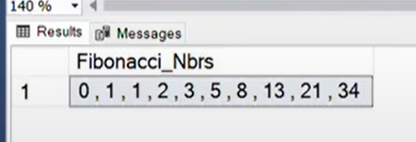

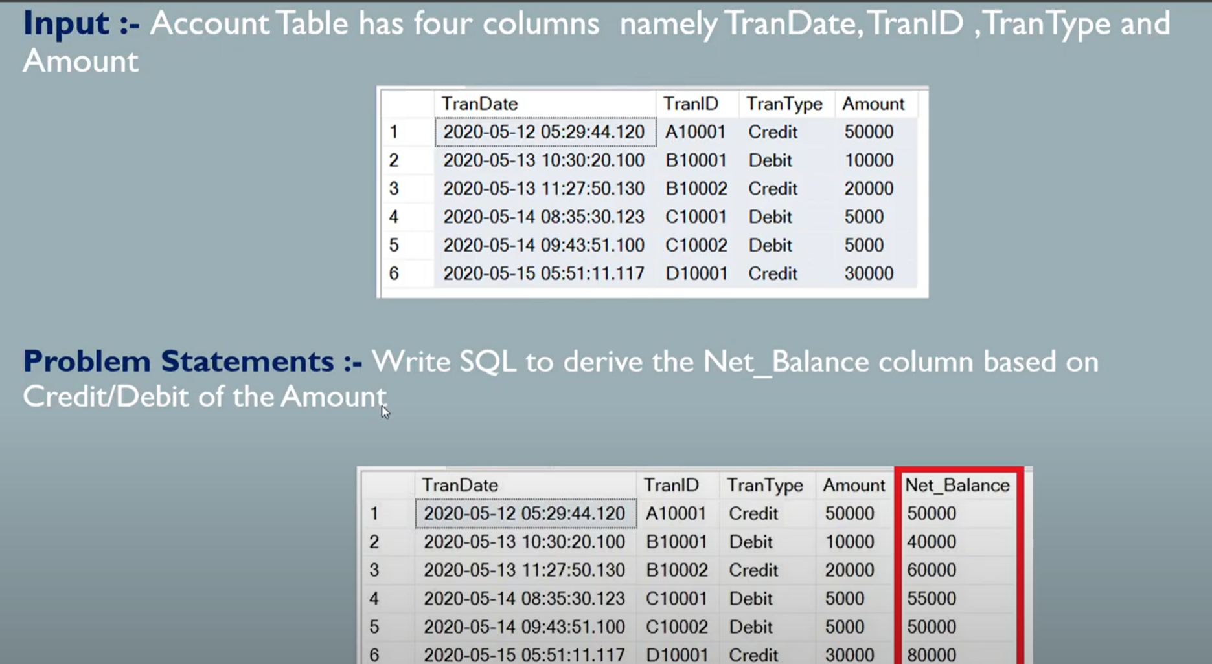

**Q3). Find the Net_Balance Amount based on the Credit and Debit ?.**

SELECT TRANS_DATE, TRANS_ID, TRANS_TYPE,AMOUNT, SUM(TEMP_AMOUNT) OVER(ORDER BY TRANS_DATE) AS NET_BALANCE

FROM

(SELECT TRANS_DATE, TRANS_ID, TRANS_TYPE,AMOUNT,

CASE WHEN TRANS_TYPE ='Credit' THEN AMOUNT

     WHEN TRANS_TYPE ='Debit' THEN AMOUNT*-1 THEN TEMP_AMOUNT

)

************************With the CTE********************

WITH CTE AS

(SELECT TRANS_DATE, TRANS_ID, TRANS_TYPE,AMOUNT,

CASE WHEN TRANS_TYPE ='Credit' THEN AMOUNT

     WHEN TRANS_TYPE ='Debit' THEN AMOUNT*-1 THEN TEMP_AMOUNT

)

SELECT TRANS_DATE, TRANS_ID, TRANS_TYPE,AMOUNT, SUM(TEMP_AMOUNT) OVER(ORDER BY TRANS_DATE) AS NET_BALANCE

FROM CTE

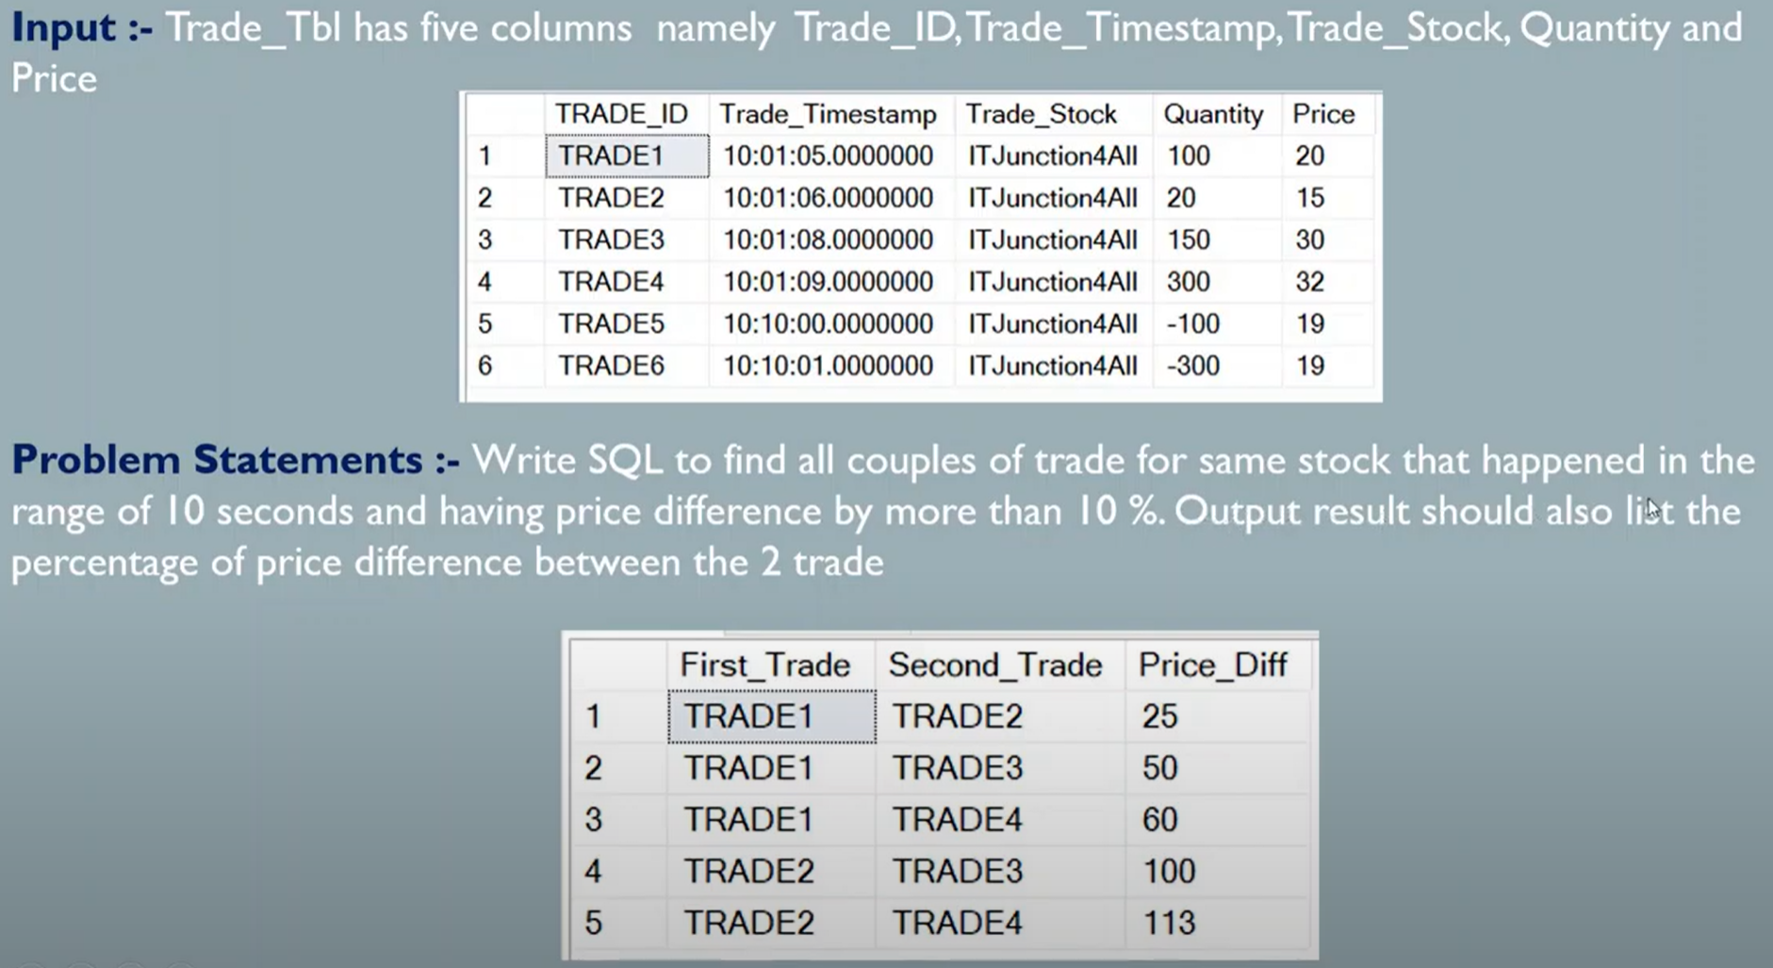

**Q3). Find the Traders for same stock?.**

With TRADE_CTE as (

    SELECT TRADE_ID, TRADE_TIMESTAMP,PRICE FROM TRADE_TABLE           ----ABS(-25)-->25

)

    SELECT A.TRADE_ID First_Trade,B.TRADE_ID Second_Trade,             ----FLOOR(100.24)-->100

    FLOOR(ABS(((B.PRICE-A.PRICE)/A.PRICE)*100)) as Price_Diff

FROM TRADE_CTE AS A

INNER JOIN  TRADE_CTE AS B

ON A.TRADE_ID<B.TRADE_ID

WHERE SECONDS_BETWEEN(A.TRADE_TIMESTAMP, B.TRADE_TIMESTAMP)<=10

AND  FLOOR(ABS(((B.PRICE-A.PRICE)/A.PRICE)*100))>=10

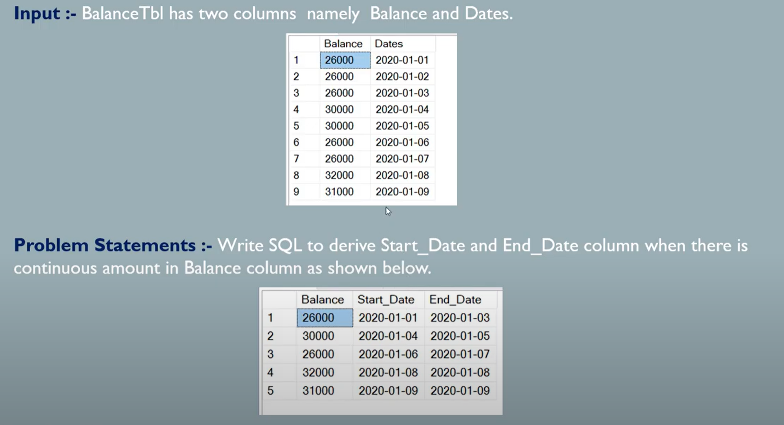

WITH Balance_CTE as

(

SELECT Balance, Dates, LAG(Balance) OVER(order by Dates) as lag_Balance,

CASE WHEN LAG(Balance) OVER(order by Dates) =  Balance THEN 0 ELSE 1 END as TempSeq

FROM BALANCE_TABLE

),

Sequence_CTE as

(

  SELECT Balance, Dates, SUM(TempSeq) OVER(ORDER BY DATES) AS SEQ

  FROM Balance_CTE

)

SELECT Balance,

Min(Dates) as Start_Date,

Max(Dates) as End_Date,

FROM Sequence_CTE

GROUP BY SEQ, Balance

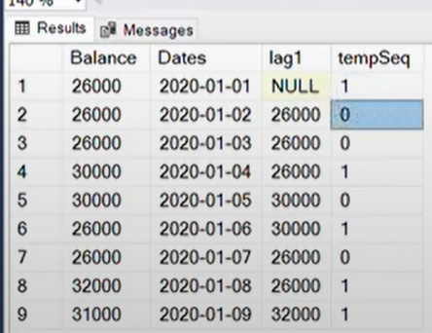

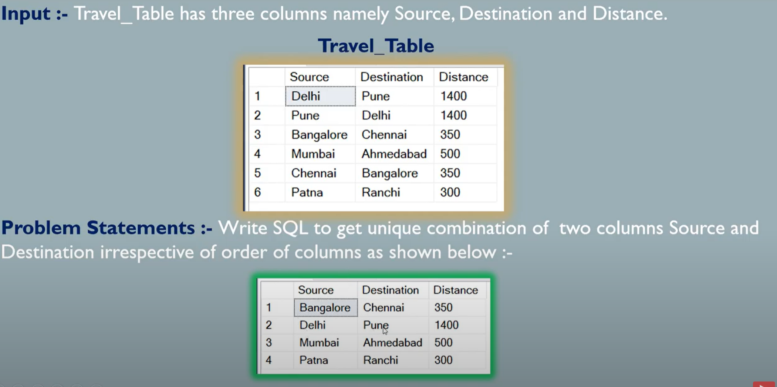

**Q3). Find the Unique combination source and destination?**

SELECT * FROM TRAVEL WHERE SOURCE<DESTINATION

UNION

SELECT * FROM TRAVEL as A

WHERE not exists (SELECT 1 FROM TRAVEL as B

                    WHERE A.SOURCE= B.DESTINATION)

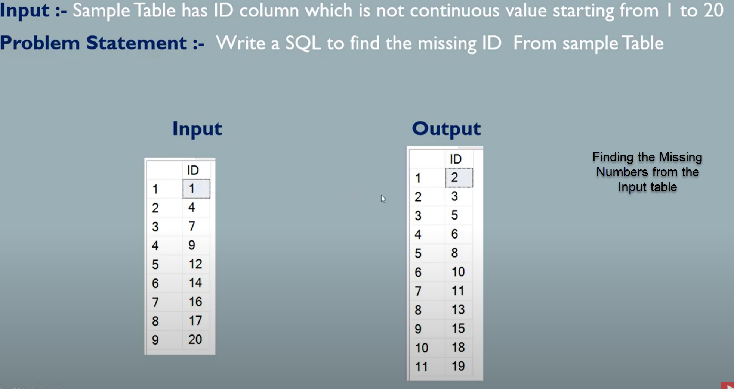

**Q3). Find the missing numbers from the input table?**

WITH CTE_A(

SELECT MAX(ID) MAxid FROM Numbers_Table

)

WITH CTE_B as

(

SELECT Min(ID) as ID FROM Number_Table

UNION ALL

SELECT B.ID+1 FROM CTE_A as A INNER JOIN CTE_B as B

WHERE B.ID<A.MAxid

)

SELECT B.ID FROM CTE_B AS B LEFT OUTER JOIN  Numbers_Table AS C

ON B.ID = C.ID

WHERE C.ID IS NULL

**Q3). Converting the data from Rows to columns?**

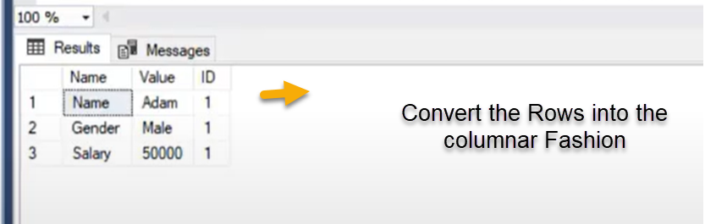

**Result**

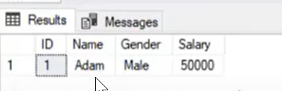

SOLUTION:-

SELECT ID,

max(CASE WHEN NAME = 'NAME' Then Value ELSE '' End) as NAME

max(CASE WHEN NAME = 'GENDER' Then Value ELSE '' End) as GENDER

max(CASE WHEN NAME = 'SALARY' Then Value ELSE '' End) as SALARY

FROM EMPLOYEE

GROUP BY ID

**Q4). Sorting out the salary by month Name i.e display the salary from Jan to Desc**

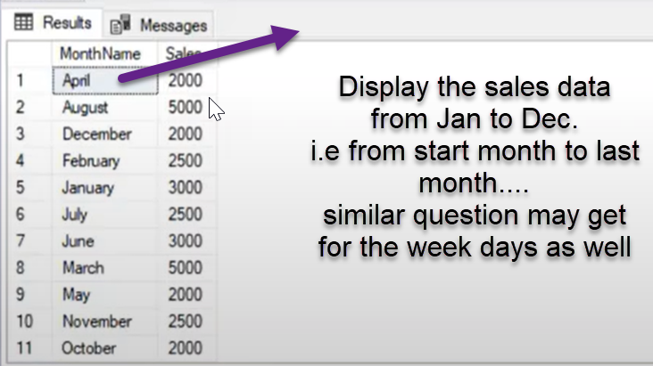

SOLUTION:-

with sales as(SELECT MonthName, CASE WHEN MonthName ='January' then 1

WHEN MonthName ='Feburay' then 2

WHEN MonthName ='March' then 3

WHEN MonthName ='April' then 4

WHEN MonthName ='May' then 5

WHEN MonthName ='June' then 6

WHEN MonthName ='July' then 7

WHEN MonthName ='Augst' then 8

WHEN MonthName ='Sep' then 9

WHEN MonthName ='Oct' then 10

WHEN MonthName ='Nov' then 11

WHEN MonthName ='Dec' then 12

else

0 end monthnumbers, Sales from SALES

)

select MonthName, sales from sales

order by monthnumbers asc

**Q5). Comparing the Previous Quarter sales data with the current quarter sales**

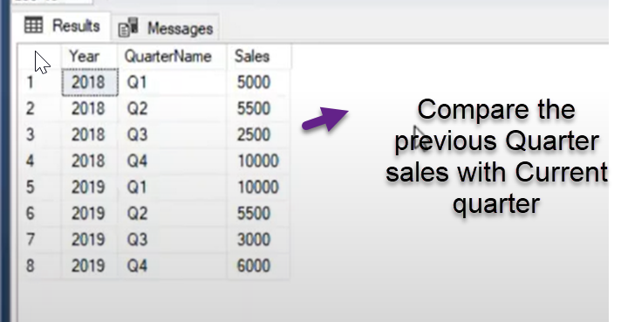

SOLUTION:- SELECT YEAR, QuarterName, Sales as current sales

lag(Sales) over(partition by year order by Quarter ASC) as Previous_Qurtersales

FROM SALES_DATA

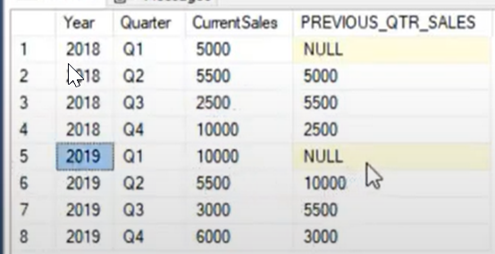

SELECT YEAR, QuarterName, Sales as current sales

lag(Sales, 2) over(partition by year order by Quarter ASC) as Previous_Qurtersales

FROM SALES_DATA

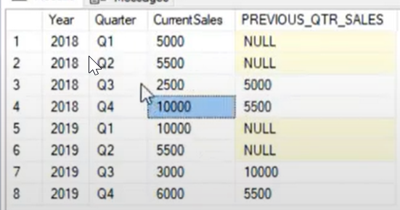

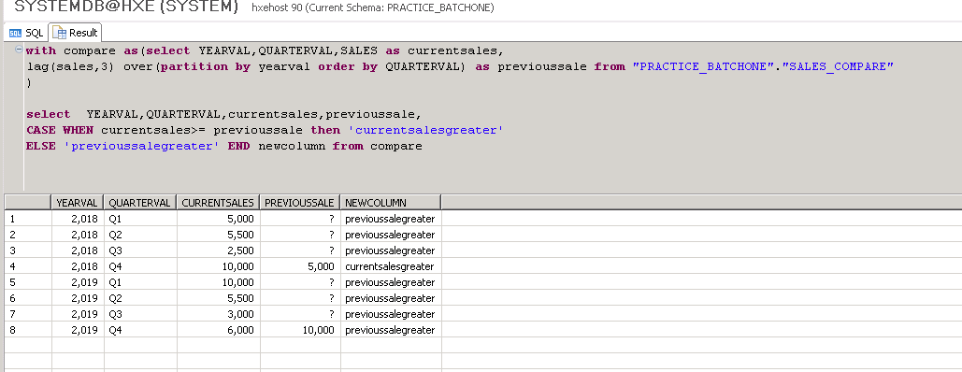

**Q5). Replace special and control characters from the Address column data**

SOLUTION:-

Select firstname,lastname, email, Address, replace(replace(Addresss,' ',''),'@@','') from EMPLOYEE

**Q6) Identifying the Employee name which doesn’t have special characters**

SOLUTION:-

Select email, Employeename From EmployeeTable

Where Employeename like ‘%[^a-z0-9]%’

**Q6) Extracting the only the character from employee name which has both the alphabets and numbers**

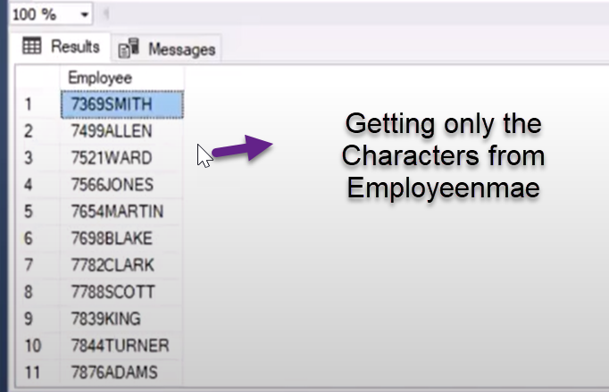

SOLUTION:-

Select EmployeeName, replace_regexpr(‘\d’ in ‘Varapr123prasad’ with ‘’) as cleansed_Employee From EMPLOYEE

**Q6) Running or Cumulative sum**

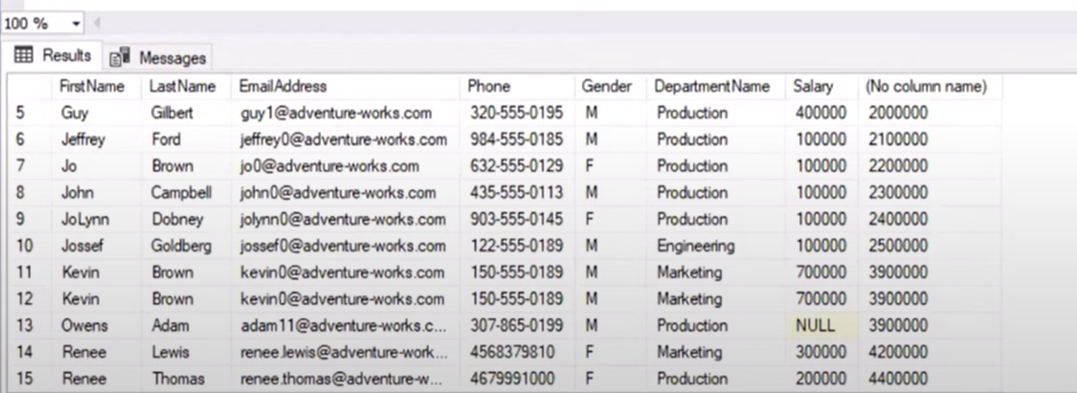

select sum(salary) over(order by employeename) from Employee

**Running Total according to the department**

select sum(salary) over(partition by department order by employeename) from Employee

**Q6) Calaculating the YTD and MTD sales**

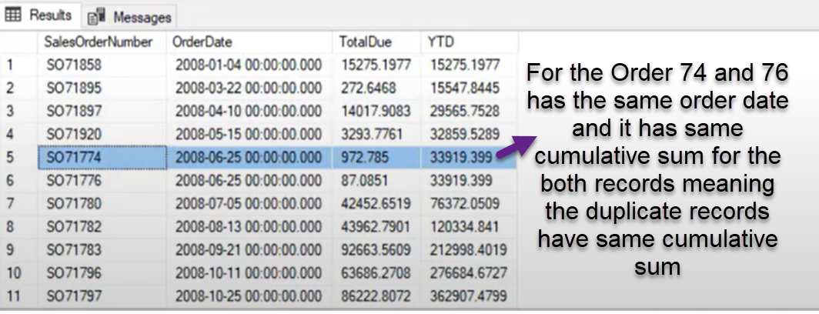

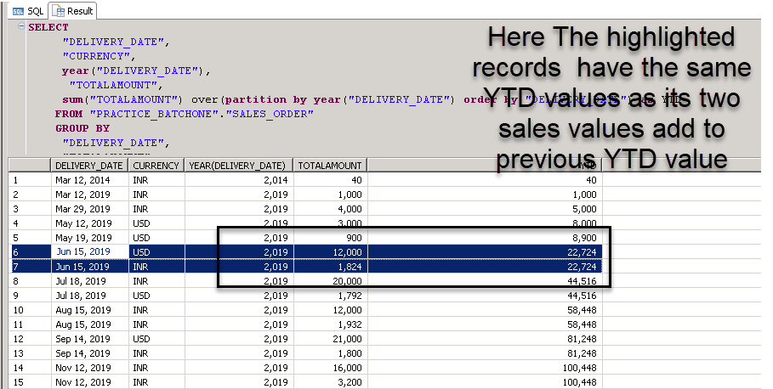

**We can handle above mentioned kind issues by using the window framing functions**

SOLUTION:-

SELECT salesordereNumber, orderdate,TotalDue,

SUM(TotalDue) over(partition by year(orderdate) order by orderdate) as YTD

SUM(TotalDue) over(partition by year(orderdate) order by orderdate rows between unbound preceding AND current row) as YTD_FRAME

FROM SALES_ORDER

Hello Everyone,

Today I came across the Danny Ma SQL Case Study challenges and I thought it would be a good way to finish the year of 2022 with some learnings.

So, I quickly started solving the Danny Maa Dinner Case study challenges to kickstart of start of the new year with learning more sql challenges in 2023.

Here is the Danny Maa Dinner Case study challenges

1. What is the total amount each customer spent at the restaurant?

SELECT a.customer_id, SUM(b.price) as Totall_Spent

FROM sales as a inner join menu as b

ON a.product_id = b.product_id

GROUP BY

a.customer_id

2. How many days has each customer visited the restaurant?

SELECT distinct customer_id,COUNT(DISTINCT (order_date)) OVER(partition by customer_id ) as visited

FROM sales

3. What was the first item from the menu purchased by each customer?

WITH CTE as (SELECT "customer_id", "order_date", a."product_id",product_name,

min("order_date") OVER(partition by customer_id) as Min_Date

FROM sales as a inner join menu as b

ON a.product_id = b.product_id

order by "customer_id" asc)

SELECT "customer_id",product_name

FROM CTE

WHERE "order_date"=Min_Date

GROUP BY

"customer_id",product_name

4. What is the most purchased item on the menu and how many times was it purchased by all customers?

Select Top 1 M.product_name , Count(S.product_id)

From Menu a

join Sales b

On a.product_id = b.product_id

Group by a.product_name

Order by Count(b.product_id) desc

5. Which item was the most popular for each customer?

WITH CTE as (SELECT "customer_id","product_id", COUNT("product_id") as CNT

FROM Sales

GROUP BY

"customer_id","product_id"),

CTE2 as(

SELECT "customer_id",product_id, CNT,

max(CNT) over(partition by "customer_id") as max

from CTE

"customer_id")

SELECT "customer_id",a.product_id, product_name from CTE2 as a inner join Menu as b

ON a.product_id = b.product_id

where CNT=max

order by "customer_id" asc

6. Which item was purchased first by the customer after they became a member?

WITH CTE as (SELECT a."customer_id","order_date","join_date","product_id",

DENSE_RANK() OVER(partition by a.customer_id order by order_date) as RENK

FROM Sales as a inner join Members as b

ON a.customer_id = b.customer_id

AND a."order_date">=join_date

order by a."order_date" asc

)

select "customer_id","order_date","product_name" from CTE as a inner join

Menu as b

on a.product_id = b.product_id

where RENK=1

7. Which item was purchased just before the customer became a member?

WITH CTE AS(SELECT a."customer_id","join_date","order_date","product_id"

FROM Sales as a inner join Members as b

ON a.customer_id = b.customer_id

AND a."order_date"<join_date

order by a."customer_id" asc

),

CTE1 as(SELECT customer_id,order_date,

max(order_date) as Date_Before_member from CTE

GROUP BY

customer_id)

SELECT c."customer_id",product_name FROM CTE as c

Inner join CTE1 as d

ON c."customer_id" = d."customer_id"

AND c."order_date" = d.Date_Before_member

inner join Menu as e

on c.product_id = e.product_id

-- 8. What is the total items and amount spent for each member before they became a member?

SELECT a.customer_id, COUNT(DISTINCT a.product_id) AS unique_menu_item, SUM(c.price) AS total_sales

FROM sales AS a

JOIN members AS b

ON a.customer_id = b.customer_id

JOIN menu AS c

ON a.product_id = c.product_id

WHERE a.order_date < b.join_date

GROUP BY a.customer_id;

-- 9. If each $1 spent equates to 10 points and sushi has a 2x points multiplier - how many points would each customer have?

SELECT customer_id,

SUM(CASE WHEN product_name ='sushi' THEN price*20

ELSE

price*10 END) as Points

FROM sales AS a

INNER JOIN menu AS b

ON a.product_id = b.product_id

GROUP BY

customer_id

This Document contains all my SQL solutions from Leetcode website in order to practice my SQL programming skills. I attempted all questions in 25 days to corroborate my knowledge in SQL.

**EASY QUESTIONS : -**

**Q1. Actors who cooperated with Directors at least three Times’s**

**Table: ActorDirector**

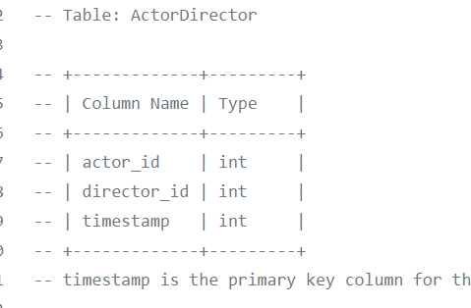

**timestamp is the primary key column for this table.**

**Write a SQL query for a report that provides the pairs (actor_id, director_id) where the actor have cooperated with the director at least 3 times.**

**Example:**

**Actor Director table:**

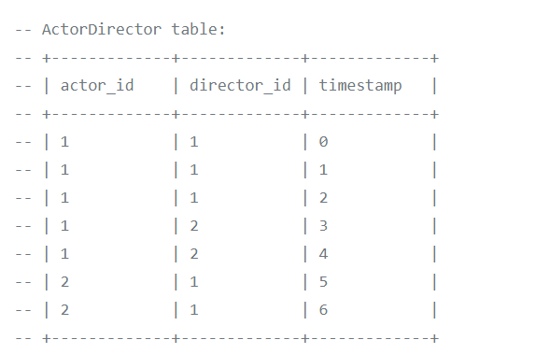

|  |
| --- |
|  |
| **Result** |
|  | +-------------+-------------+ |
|  | | actor_id | director_id | |
|  | +-------------+-------------+ |
|  | | 1 | 1 | |
|  | -- +-------------+-------------+ |
|  | The only pair is (1, 1) where they cooperated exactly 3 times. |
|  |  |

**-- Solution**

**Select actor_id, director_id**

**from actordirector**

**group by actor_id, director_id**

**having count(*)>=3**

## **Q2) Ads performance’s sql**

|  |  |
| --- | --- |
| **Column Name** | **Type** |
| ad_id | int |
| user_id | int |
| Action | enum |

**(ad_id, user_id) is the primary key for this table.**

**Each row of this table contains the ID of an Ad, the ID of a user and the action taken by this user regarding this Ad.**

**The action column is an ENUM type of ('Clicked', 'Viewed', 'Ignored').**

**A company is running Ads and wants to calculate the performance of each Ad.**

**Performance of the Ad is measured using Click-Through Rate (CTR) where:**

**Write an SQL query to find the ctr of each Ad.**

**Round ctr to 2 decimal points. Order the result table by ctr in descending order and by ad_id in ascending order in case of a tie.**

**The query result format is in the following example:**

**Ads table**

|  |  |  |
| --- | --- | --- |
| **ad_id** | **user_id** | **action** |
|  |  |  |
| 1 | 1 | Clicked |
| 2 | 2 | Clicked |
| 3 | 3 | Viewed |
| 5 | 5 | Ignored |
| 1 | 7 | Ignored |
| 2 | 7 | Viewed |
| 3 | 5 | Clicked |
| 1 | 4 | Viewed |
| 2 | 11 | Viewed |
| 1 | 2 | Clicked |

**-- Result table:**

|  |  |
| --- | --- |
| **ad_id** | **ctr** |
| **1** | **66.67** |
| **3** | **50** |
| **2** | **33.33** |
| **5** | **0** |

-- Solution

with t1 as (select ad_id, sum(case when action in ('Clicked') then 1 else 0 end) as clicked

from ads

group by ad_id),

t2 as (

Select ad_id as ad, sum(case when action in ('Clicked','Viewed') then 1 else 0 end) as total

from ads

group by ad_id)

Select a.ad_id, coalesce(round((clicked +0.0)/nullif((total +0.0),0)*100,2),0) as ctr

From (select *

from t1 join t2

on t1.ad_id = t2.ad) a

order by ctr desc, ad_id

**Q3) Article views.sql**

**Table views**

|  |  |
| --- | --- |
| **Column Name** | **Type** |
| article_id | Int |
| author_id | Int |
| viewer_id | Int |
| view_date | Date |

**There is no primary key for this table, it may have duplicate rows.**

**Each row of this table indicates that some viewer viewed an article (written by some author) on some date.**

**Note that equal author_id and viewer_id indicate the same person.**

**---Write an SQL query to find all the authors that viewed at least one of their own articles, sorted in ascending order by their id.**

**The query result format is in the following example:**

**Views table:**

|  |  |  |  |
| --- | --- | --- | --- |
| article_id | author_id | viewer_id | view_date |
| 1 | 3 | 5 | 8/1/2019 |
| 1 | 3 | 6 | 8/2/2019 |
| 2 | 7 | 7 | 8/1/2019 |
| 2 | 7 | 6 | 8/2/2019 |
| 4 | 7 | 1 | 7/22/2019 |
| 3 | 4 | 4 | 7/21/2019 |
| 3 | 4 | 4 | 7/21/2019 |

|  |
| --- |
| Id |
| 4 |
| 7 |

-- Solution

select distinct author_id as id

from views

where author_id = viewer_id

order by author_id\

**Q4) Average selling price.sql**

**Table: Prices**

|  |  |
| --- | --- |
| **Column Name** | **Type** |
| product_id | Int |
| start_date | Date |
| end_date | Date |
| Price | Int |

**(product_id, start_date, end_date) is the primary key for this table.**

**Each row of this table indicates the price of the product_id in the period from start_date to end_date.**

**For each product_id there will be no two overlapping periods. That means there will be no two intersecting periods for the same product_id.**

**Table: UnitsSold**

|  |  |
| --- | --- |
| **Column Name** | **Type** |
| product_id | Int |
| purchase_date | Date |
| Units | Int |

**There is no primary key for this table, it may contain duplicates.**

**Each row of this table indicates the date, units and product_id of each product sold.**

**Write an SQL query to find the average selling price for each product.**

**The average price should be rounded to 2 decimal places.**

**The query result format is in the following example:**

**Prices table:**

|  |  |  |  |
| --- | --- | --- | --- |
| **product_id** | **start_date** | **end_date** | **price** |
| 1 | 2/17/2019 | 2/28/2019 | 5 |
| 1 | 3/1/2019 | 3/22/2019 | 20 |
| 2 | 2/1/2019 | 2/20/2019 | 15 |
| 2 | 2/21/2019 | 3/31/2019 | 30 |

**UnitsSold table:**

|  |  |  |
| --- | --- | --- |
| **product_id** | **purchase_date** | **units** |
| 1 | 2/25/2019 | 100 |
| 1 | 3/1/2019 | 15 |
| 2 | 2/10/2019 | 200 |
| 2 | 3/22/2019 | 30 |

**Result table:**

|  |  |
| --- | --- |
| **product_id** | **Average_price** |
| 1 | 6.96 |
| 2 | 16.96 |

**Average selling price = Total Price of Product / Number of products sold.**

**Average selling price for product 1 = ((100 * 5) + (15 * 20)) / 115 = 6.96**

**Average selling price for product 2 = ((200 * 15) + (30 * 30)) / 230 = 16.96**

-- Solution

Select d.product_id, round((sum(price*units)+0.00)/(sum(units)+0.00),2) as average_price

from(

Select *

from prices p

natural join

unitssold u

where u.purchase_date between p.start_date and p.end_date) d

group by d.product_id

## **Q5) Big Countries.sql**

**There is a table World**

|  |  |  |  |  |
| --- | --- | --- | --- | --- |
| **name** | **continent** | **area** | **population** | **Gdp** |
| Afghanistan | Asia | 652230 | 25500100 | 20343000 |
| Albania | Europe | 28748 | 2831741 | 12960000 |
| Algeria | Africa | 2381741 | 37100000 | 188681000 |
| Andorra | Europe | 468 | 78115 | 3712000 |
| Angola | Africa | 1246700 | 20609294 | 100990000 |

**A country is big if it has an area of bigger than 3 million square km or a population of more than 25 million.**

**Write a SQL solution to output big countries' name, population and area.**

**For example, according to the above table, we should output:**

|  |  |  |
| --- | --- | --- |
| **name** | **population** | **area** |
| Afghanistan | 25500100 | 652230 |
| Algeria | 37100000 | 2381741 |

Solution

Select name, population, area

from world

where population > 25000000 OR area>3000000

**Question7**

**There is a table courses with columns: student and class**

**Please list out all classes which have more than or equal to 5 students.**

**For example, the table:**

|  |  |
| --- | --- |
| **student** | **class** |
| A | Math |
| B | English |
| C | Math |
| D | Biology |
| E | Math |
| F | Computer |
| G | Math |
| H | Math |
| I | Math |

-- Solution

select class

from courses

group by class

having count(distinct student)>=5

## **Q8).Combine two tables.sql**

**Table: Person**

|  |  |
| --- | --- |
| **Column Name** | **Type** |
| PersonId | int |
| FirstName | varchar |
| LastName | varchar |

**PersonId is the primary key column for this table.**

**Table: Address**

|  |  |
| --- | --- |
| **Column Name** | **Type** |
| AddressId | int |
| PersonId | int |
| City | varchar |
| State | varchar |

**AddressId is the primary key column for this table.**

**Write a SQL query for a report that provides the following information for each person in the Person table, regardless if there is an address for each of those people:**

**FirstName, LastName, City, State**

-- Solution

select FirstName, LastName, City, State

from Person P left join Address A

on P.PersonId = A.PersonId

## **Q8). Create Session bar chart.sql**

**Table: Sessions**

|  |  |
| --- | --- |
| Column Name | Type |
| session_id | int |
| duration | int |

session_id is the primary key for this table.

duration is the time in seconds that a user has visited the application.

You want to know how long a user visits your application. You decided to create bins of "[0-5>", "[5-10>", "[10-15>" and "15 minutes or more" and count the number of sessions on it.

**Write an SQL query to report the (bin, total) in any order.**

The query result format is in the following example.

|  |  |
| --- | --- |
| **session_id** | **duration** |
| 1 | 30 |
| 2 | 199 |
| 3 | 299 |
| 4 | 580 |
| 5 | 1000 |

**Result table:**

|  |  |
| --- | --- |
| **bin** | **total** |
| [0-5> | 3 |
| [5-10> | 1 |
| [10-15> | 0 |
| 15 or more | 1 |

**For session_id 1, 2 and 3 have a duration greater or equal than 0 minutes and less than 5 minutes.**

**For session_id 4 has a duration greater or equal than 5 minutes and less than 10 minutes.**

**There are no session with a duration greater or equial than 10 minutes and less than 15 minutes.**

**For session_id 5 has a duration greater or equal than 15 minutes.**

-- Solution 2

(Select '[0-5>' as bin,

 sum(case when duration/60 < 5 then 1 else 0 end) as total from Sessions)

 union

(Select '[5-10>' as bin,

 sum(case when ((duration/60 >= 5) and (duration/60 < 10)) then 1 else 0 end) as total from Sessions)

 union

(Select '[10-15>' as bin,

 sum(case when ((duration/60 >= 10) and (duration/60 < 15)) then 1 else 0 end) as total from Sessions)

 union

(Select '15 or more' as bin,

 sum(case when duration/60 >= 15 then 1 else 0 end) as total from Sessions)